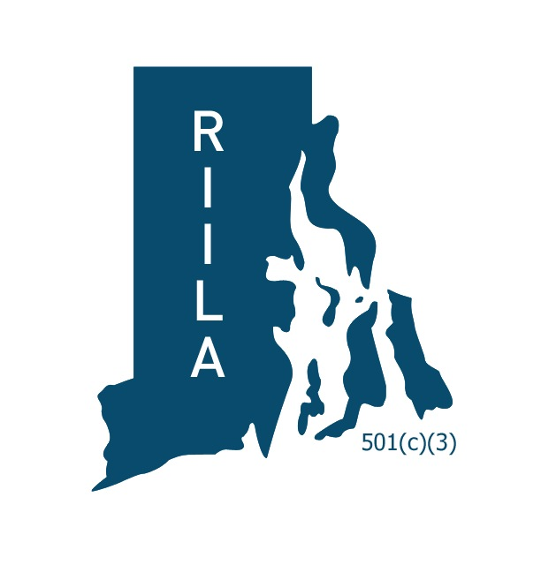

RIASP/RIILA Annual Summer Conference
INNOVATE ‘18

REQUEST TO PRESENT: Wednesday, August 8th

Submit “Request to Present” Form by Friday, March 16, 2018
to Sherry sarliapuhacz@riasp.org.

- Name of Presenter(s): (list all presenters (names, title and school)

- Area of Focus:

- Title of Session:

- Session Description:

- Results: What should attendees expect to take away from this session (skills, knowledge, resources, etc.)?

